**Air Asia Experience Application**

**Outline**

We have created a sample Air Asia experience application

There are three parts to the application UI:

1. Part that reads in booking URL
2. Pre Flight Customization
3. Post Flight Customization

**Screenshot**

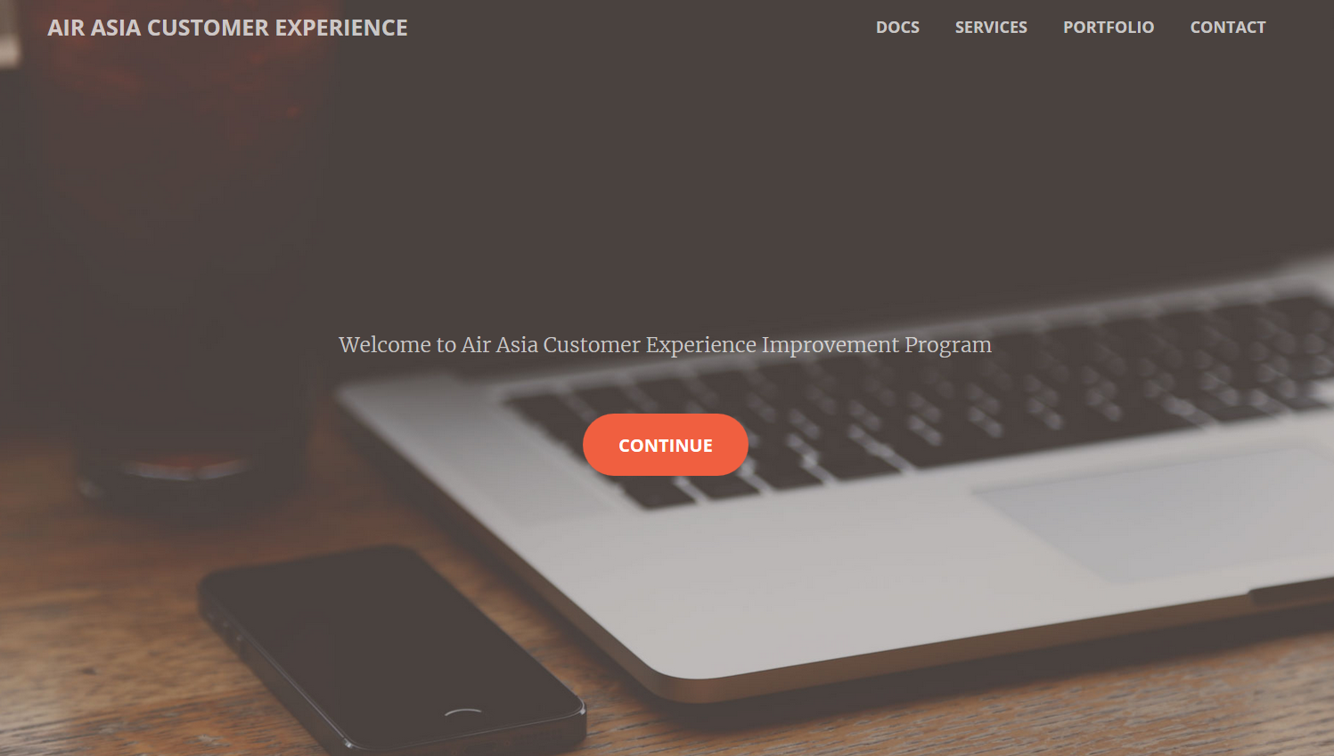

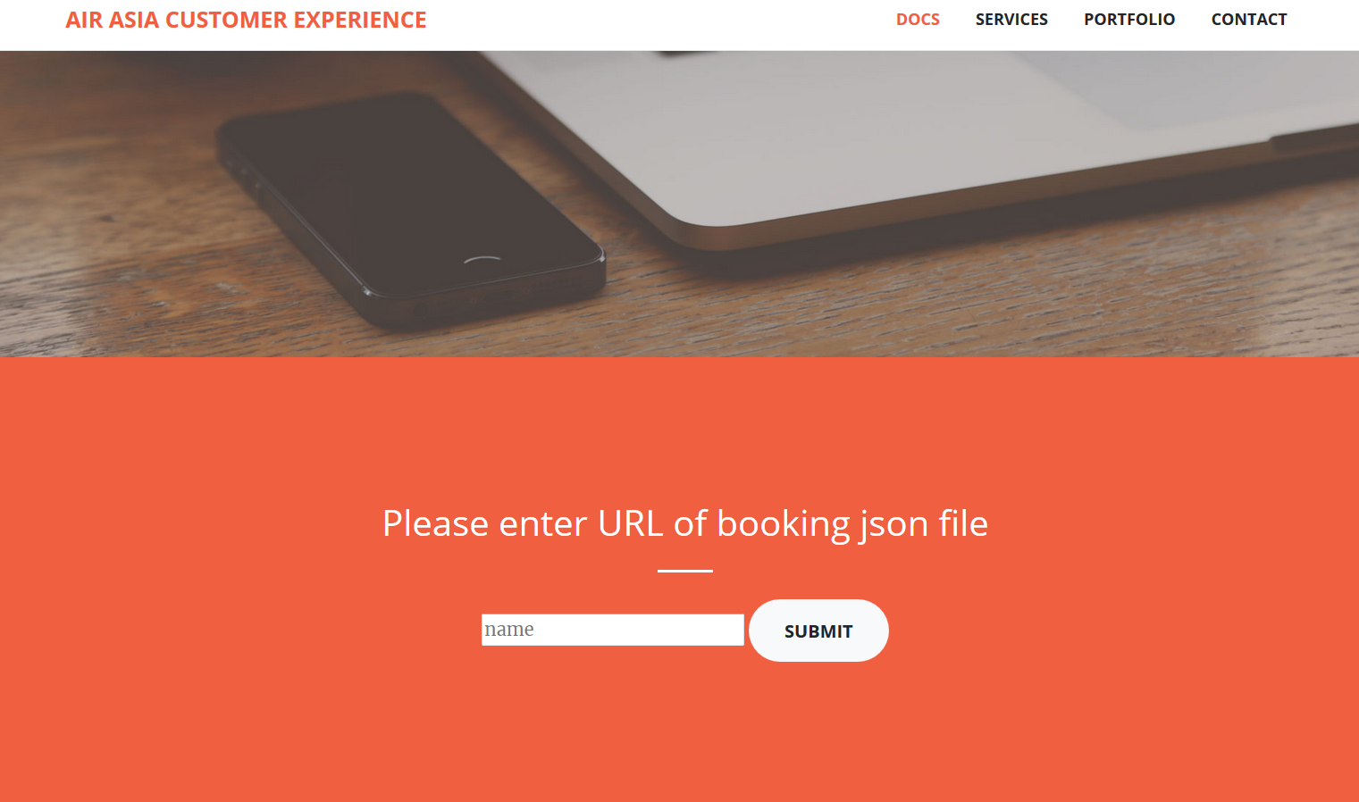

**API Interfacing**

We have created a couple of API calls

POST /uploadJson – this accepts the URL of the booking file and fetches the booking and stores it into database

POST /preflight – this accepts the preflight Customization of user with id and stores it

POST /postflight – this accepts the preflight Customization of user with id and stores it

**Steps to run**

cd AirAsiaHackathon

run npm install

run npm start

open <http://localhost:3000> on browser

**Why this application is better:**

* It separates ui calls from api calls which can later be used to make a scalable application

**Credits**

**Template from** [Start Bootstrap - Free Bootstrap Themes and Templates](https://startbootstrap.com/)

DB on: https://mlab.com/home